Qualifier Exam
(Political Economy II, Summer 2012)

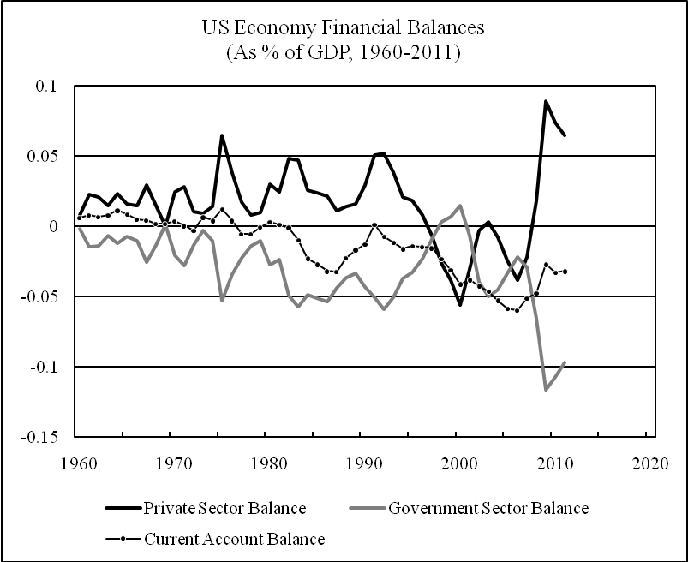

- Based on your reading of Keynes (General Theory, Chapter 12), Li (on the Minsky Paradox) and Levy Economics Institute (Strategic Analysis), answer the following questions. Why was small government capitalism fundamentally unstable? Did the development of financial markets help to alleviate or exacerbate the instability of capitalism? What was the Minsky Paradox? Using the information presented in the above graph, discuss how the big government capitalism has become increasingly unsustainable since the 1960s (make sure to discuss how the US main sectors’ financial balances have evolved through successive phases of US economic development) .
- Based on your reading of Engels’s “Socialism: Utopian and Scientific” as well as Wallerstein, Arrighi, Navarro, Kotz, and Li’s writings on historical socialism, answer the following questions. According to Engels, what were the historical conditions that led to the separation of society into an exploiting and an exploited class? According to the Marxist and world system writers, why did the 20th century socialist states fail to achieve a classless society as the communist movement had envisioned? To what extent were the 20th century socialist revolutions historically justified or not?

